003 Angular2 - ngFor

Angular2 Kata List – Blog Page

[TypeScript Kata List on GitHub](https://github.com/robertdunaway/katas-typescript)

# Duration

5 minutes

# Brief

Use ngFor to iterate over an object.

### For More Information

BING/GOOGLE: “Angular2 ngFor”

Read eBook: <https://www.ng-book.com/2/>

<https://angular.io/docs/ts/latest/api/common/NgFor-directive.html>

# Instructions

Get tutorial folder or the entire katas-angular2 repo.

Open the [before/*.sln] file and execute the kata.

Feel free to execute this kata multiple times because repetition creates motor memory.

# Github

* Before (start kata with this)
  + https://github.com/robertdunaway/katas-angular2/tree/master/003%20Angular2%20-%20ngFor/before
* After
  + https://github.com/robertdunaway/katas-angular2/tree/master/003%20Angular2%20-%20ngFor/after

# Kata

Iterate over the Person property and display a list of users.

We already have a basic Angular2 application with a Person class. The Person class constructor populates the persons object that you will iterate over.

Us a ngFor to display a list of persons. This is similar to and the replacement for Angular1’s ngRepeat.

Your components template might end up looking something like this.

@Component({

selector: 'hello-world',

template: `

<div>

<li *ngFor='#person of persons'>{{person.FirstName}} {{person.LastName}} {{person.Email}}</li>

</div>

`

})

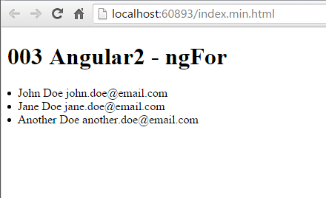

You might want to experiment with ngFor. Possibly create a dropdown control with the ngFor directive.

# Next

Take a few minutes and imagine more examples.